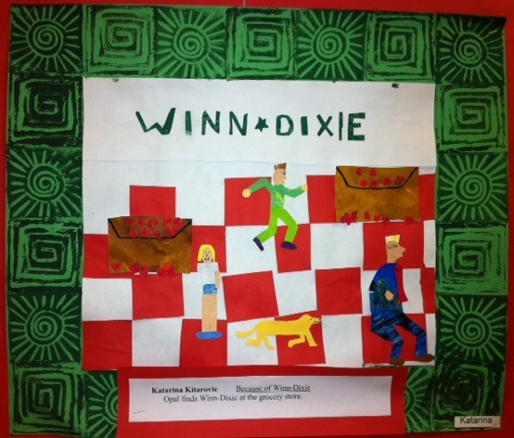
Project duration: 4 classes
Students select a scene from a current book they have read in class. We look at the narrative art of Jacob Lawrence, Faith Ringgold & William H. Johnson. Students draft ideas & select the scene that would best incorporate the repetition of elements J. Lawrence used in the Great Migration Series.

Share a brief description of the book and scene illustrated:

Jacob Lawrence applied meaning to the repetition & use of color and shape in his work. Where can we find examples of this in your collage?

Why was this particular scene important to you to illustrate? Did it challenge you as an artist?

If you could relate to one of the characters, how would that be?

Would you have changed any of the scenes or perhaps this one?

