Describe the main difference between bilateral symmetry and radial symmetry.

Which of these tiles does not demonstrates radial symmetry?

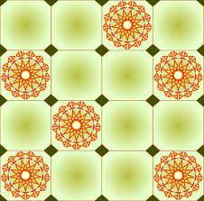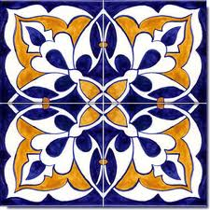

A. B. C.

Cactus Cantina, the Mexican restaurant right near our school is remodeling the main dining room! They are in need of a new ceramic tile design. The owners are looking for a tile that demonstrates radial symmetry and uses monochromatic colors (tints and shades). The owner is giving you time to sketch your plan and fill it in with color. Your tile design will be presented to the owners along with an explanation of the design elements you applied to your tile.

Please explain your design choices and how you used both radial symmetry and monochromatic colors in your design. Did you add any other Elements of Design to you tile?

